**Create your first C# Service Fabric stateful reliable services application and deploy on local server.**

**Prerequisite**:

* Visual Studio 2017 or Visual Studio 2015
* [Install the Microsoft Azure Service Fabric SDK](http://www.microsoft.com/web/handlers/webpi.ashx?command=getinstallerredirect&appid=MicrosoftAzure-ServiceFabric-CoreSDK)
* Enable PowerShell script execution

Open PowerShell as an administrator and enter the following command:

Set-ExecutionPolicy -ExecutionPolicy Unrestricted -Force -Scope CurrentUser

Step: Create a new project by clicking File + New + Project

Then Click on Cloud and select Service Fabric Appliclation and give the name to the application and click on Ok button.

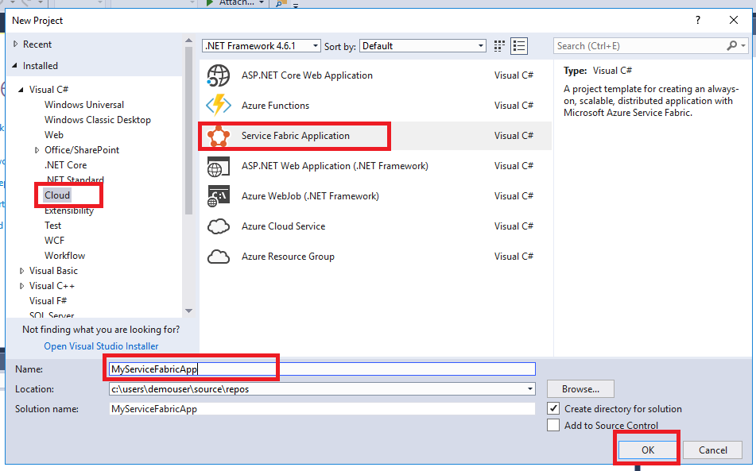

Then on next Page, select Stateful Service and give it a name and then click on ok button.

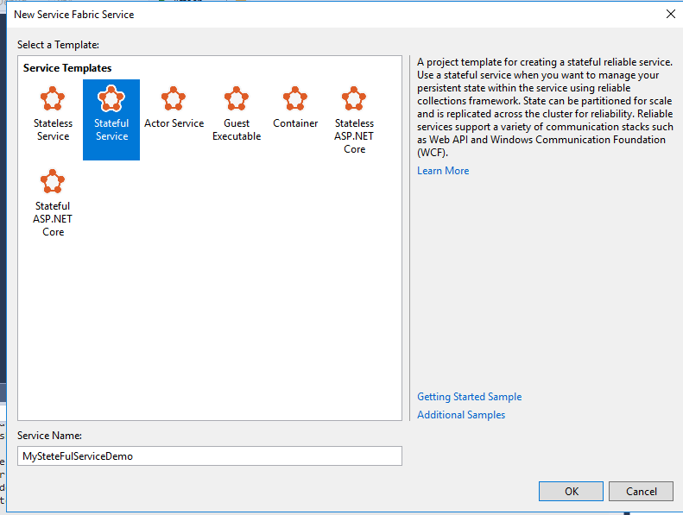

Visual Studio creates the application project and the stateful service project and displays them in Solution Explorer.

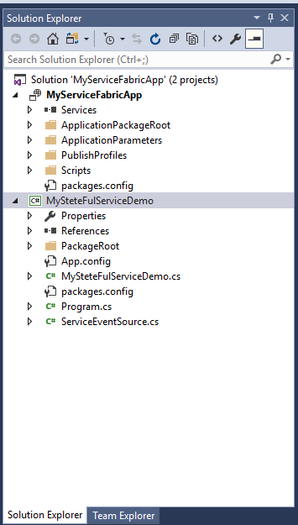

In Visual Studio, press **F5** to deploy the application for debugging.

When the cluster is ready, you see “Service Fabric Local Cluster Manager” in lower right corner of your screen. As seen in below image:

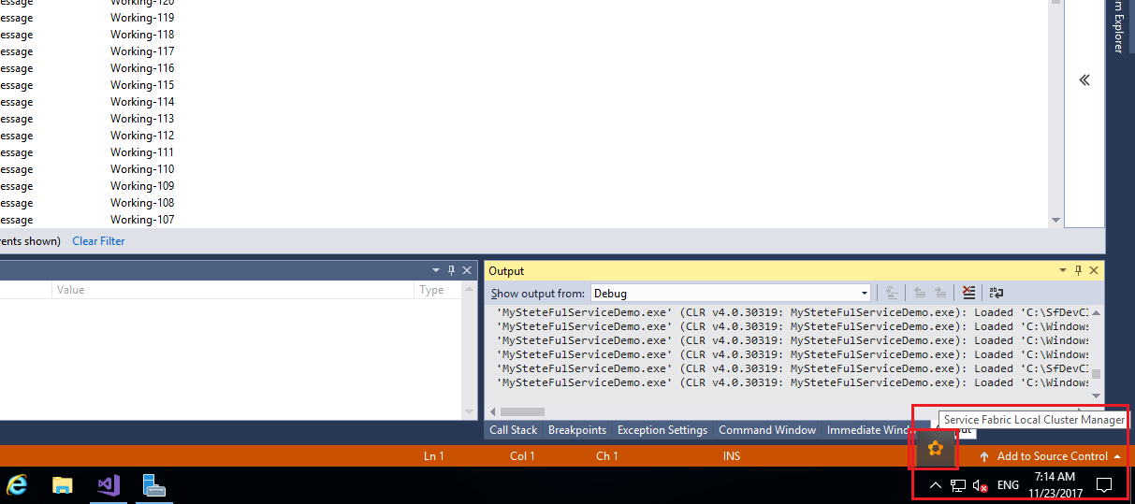

Once the application starts, Visual Studio automatically brings up the **Diagnostics Event Viewer**, where you can see trace output from your services.

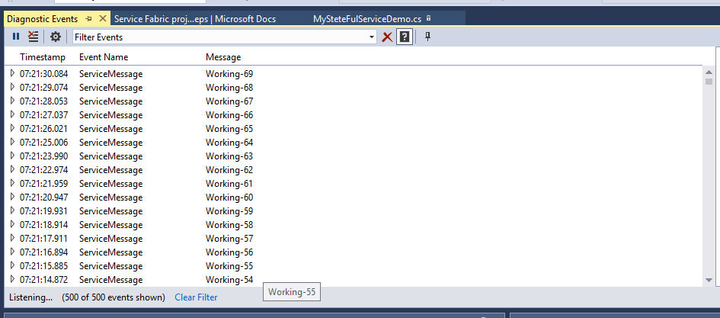

Now in the Diagnostic event Viewer, Click on Pause button.

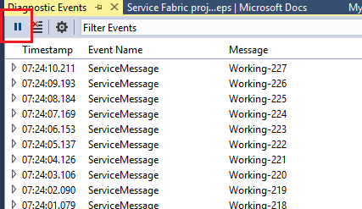

Expand one of the events to see more details, including the node where the code is running. In this case, it is _Node_2, though it may differ on your machine.

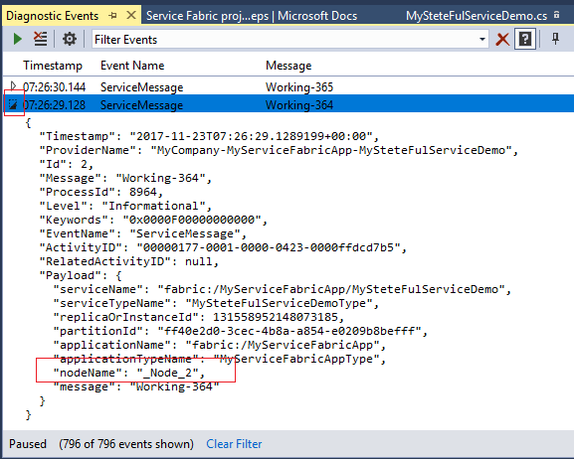

The local cluster contains five nodes hosted on a single machine. In a production environment, each node is hosted on a distinct physical or virtual machine. To simulate the loss of a machine while exercising the Visual Studio debugger at the same time, let's take down one of the nodes on the local cluster.

In the **Solution Explorer** window, open **MySteteFulServiceDemo.cs**, Find the **RunAsync** method and set a breakpoint on the first line of the method.

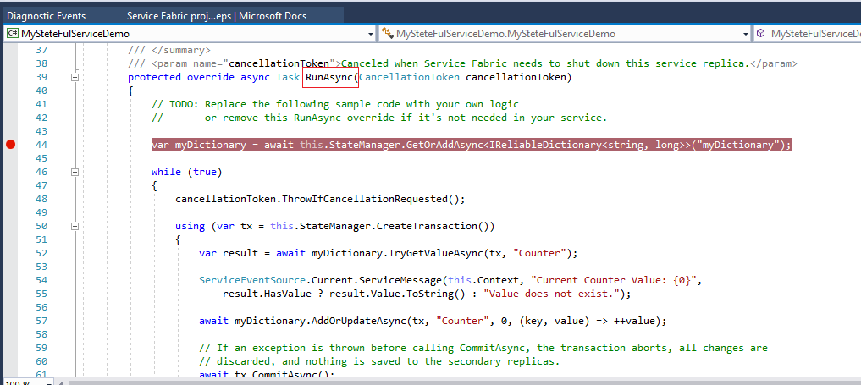

Right-clicking on the **Local Cluster Manager** system tray application and choose **Manage Local Cluster**.

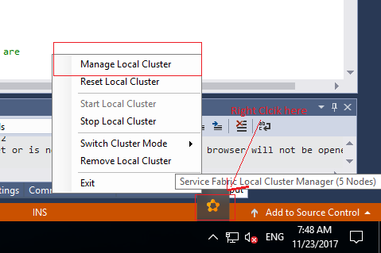

A Service Fabric Explore will open:

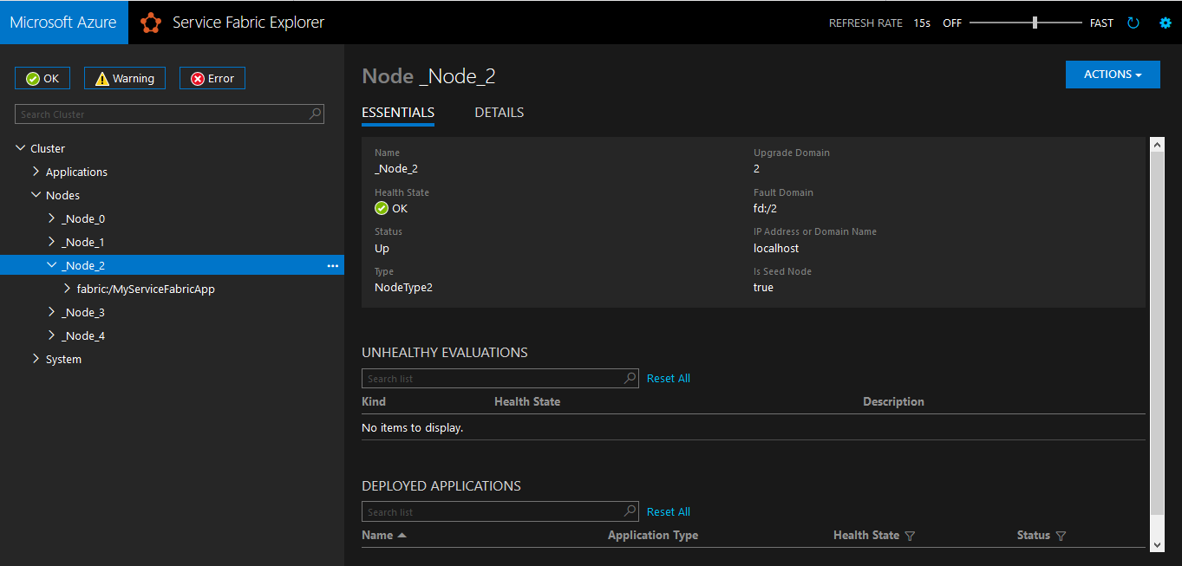

As we have seen Node-2 is giving responses that’s why we will restart it by click on _Node_2 and the Click on Action button and select Restart.

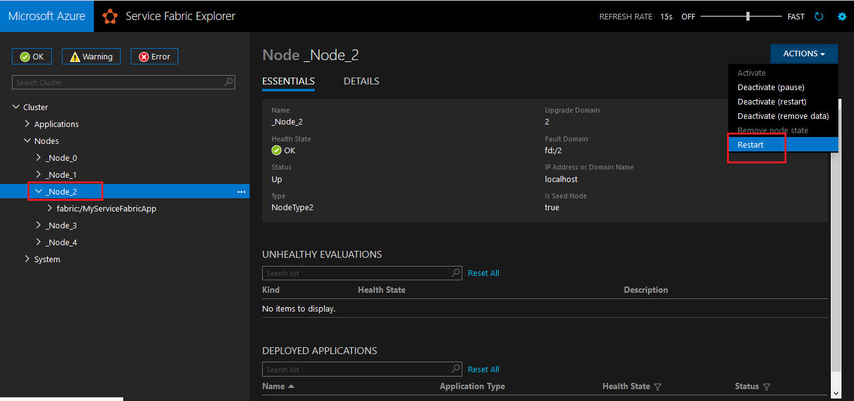

Now on new popup, type the node name _Node_2 and then click on Restart

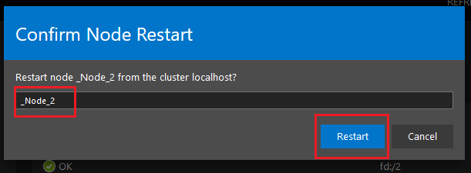

Now in the Diagnostic Event Viewer, Click on any event and expand it. You can see the response is now coming from _Node_1. So in case of failure, service fabric itself heal it by assigning a different node.

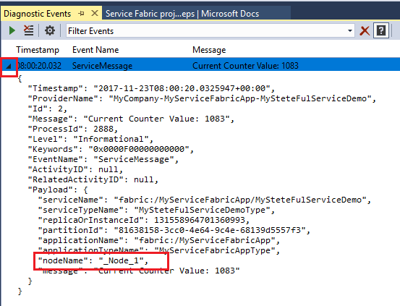

## Cleaning up the local cluster (optional)

Remember, this local cluster is real. Stopping the debugger removes your application instance and unregisters the application type. However, the cluster continues to run in the background. When you're ready to stop the local cluster, there are a couple options.

### **Keep application and trace data**

Shut down the cluster by right-clicking on the **Local Cluster Manager** system tray application and then choose **Stop Local Cluster**.

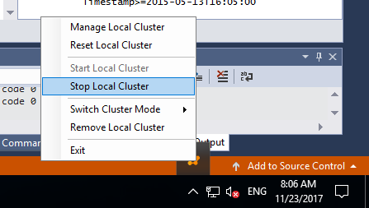

### **Delete the cluster and all data**

Remove the cluster by right-clicking on the **Local Cluster Manager** system tray application and then choose **Remove Local Cluster**.

